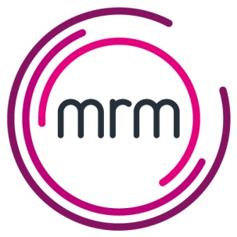

How to get paid – For Suppliers
At MRM we believe that prompt payment of our invoices is the right thing to do.
We keen to ensure that all our suppliers receive payment on time so we have put together a quick guide to help you avoid any delays.

How to submit your invoice
All invoices should be emailed to Accounts.payable@mm.co.uk and include any backup required.

Purchase Orders
All MRM purchases are made using Purchase Orders (PO Numbers) and this is a vital element of our purchase control. The PO number will be provided by the person making a purchase and should be quoted on the invoice.

What your invoice should include
- MRM Purchase Order number ( PO Number)
- The Quantity and unit price of what is being purchased
- Any references / docket numbers provided when the purchase was made
- Your company bank details
- Invoice due date
- Your contact Email address and phone number
- VAT number where appropriate
- Your business address and registered number
If any of these details are missing it may cause a delay in getting the invoices paid.

How we pay you
- All our payments are made by bank transfer.
- We complete a payment run every week.
- We email a remittance advice showing which invoices are being paid.
- The remittance shows the last 4 digits of the bank account we are making payment to.

Queries and problems
- We endeavour to resolve any queries before the invoice becomes due for payment and will seek your assistance with this.
- If there is a problem or query we will contact you as soon as possible to explain the problem and seek clarification.
- When an invoice is queried we would not normally pay it until it is resolved, but once it has reached its due date we can pay any part that has been agreed.

If you have any queries at all please email Accounts.payable@mrm.co.uk

